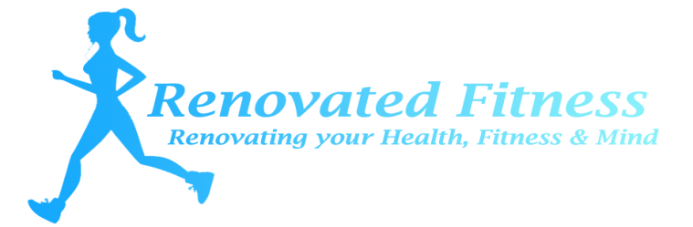
Renovated Fitness Boot Camps by Marissa Vermeulen
Boot Camp Waiver Form

I ___________________________ (print full name) have agreed to participate in the Renovated Fitness Conditioning Boot Camp by Marissa Vermeulen

I recognize that the program involves strenuous physical activity including, but not limited to, strength training, running, agility drills, jumping, intense cardiovascular activities and flexibility training.
I hereby affirm that I am in good physical condition and do not suffer from any known disability or condition which would prevent or limit my participation in this exercise program.
I acknowledge that my registration and subsequent participation in the Renovated Fitness Conditioning Boot Camp by Marissa Vermeulen
In consideration of my participation in this program, I hereby release and discharge the Renovated Fitness Conditioning Boot Camp by Marissa Vermeulen Camp Program and its agents from any claims, demands and causes of action as a result of my voluntary participation and registration in this bootcamp.

__________________________________ (Participant’s Signature) ______________________ (Date)

__________________________________ (Print name) ________________________ (Phone)

__________________________________ (Email)

_____________________________________________________ (Emergency Contact and Number)

